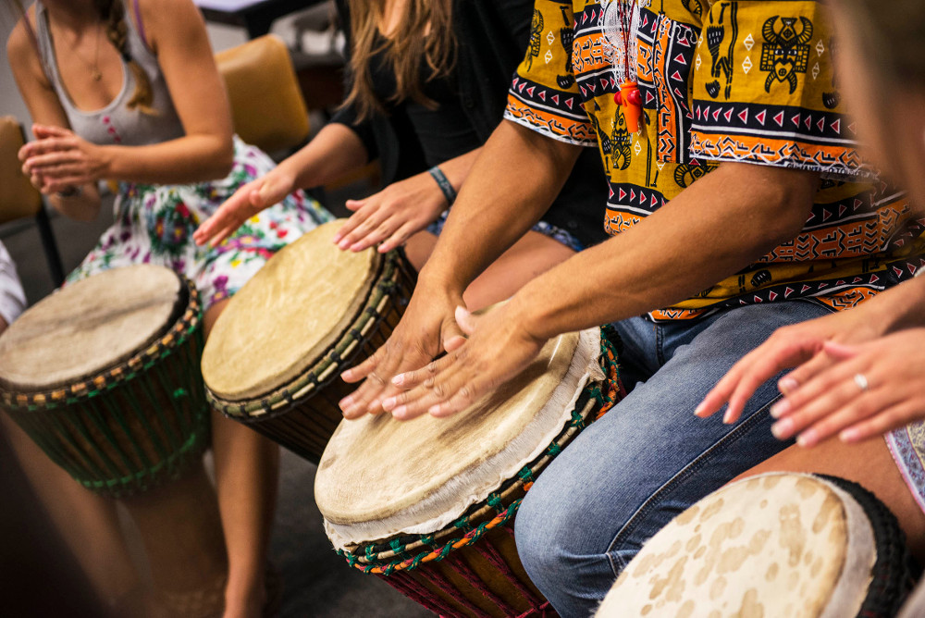

First Sunday of every month

at 10:45-11:15 AM

Downstairs in Room 3 following Sunday School

Starting Sunday, Oct. 1

(Oct. 1, Nov. 5, Dec. 3, Apr. 1, May 6, June 3)

*All Youth are Welcome!*

# UNDER THE DIRECTION OF EVAN PILLOW

* For more information, see Evan or email Marlene at [mwhittemore@christchurchridgewood.org](mailto:mwhittemore@christchurchridgewood.org)
* Marlene Whittemore, Director of Children & Youth Choirs

Youth African

Drum Ensemble